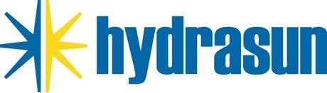

HYDRASUN POLICY STATEMENT MODERN SLAVERY ACT 2015

Hydrasun is committed to compliance with the Modern Slavery Act 2015 and to supporting global efforts to eradicate slavery and human trafficking
It is of great importance to Hydrasun that all parties within our supply chain treat their employees fairly, with dignity and respect and that they value human rights.
Hydrasun and its suppliers shall not engage in or support the use of any form of forced, compulsory or illegal labour, including human trafficking. Hydrasun require all suppliers and sub-suppliers to comply with these prohibitions on slavery, human trafficking and child labour, and to allow Hydrasun to verify compliance upon request.
Hydrasun terms and conditions of purchase apply to purchased goods and services from suppliers and impose an affirmative, legally enforceable obligation that all supplied goods and services will have been produced in compliance with all applicable laws.
Hydrasun ensures that employee compensation meets or exceeds the legal requirements and is competitive with industry standards in the countries where we do business.
A Modern Slavery Act audit is conducted by Hydrasun annually as part of its Internal Audit Schedule. Following that audit, an annual meeting is held with Senior Management to discuss Modern Slavery Act compliance and to review and update this Statement, as appropriate.
This Policy Statement is available to all staff through the company Intranet system. It is also communicated to all staff through the company Induction process.



N Thompson
Chief Executive Officer
April 2026 Document review date: April 2027

QAM-SU-PS-003

